TY B.Tech. – ARTIFICIAL INTELLIGENCE AND MACHINE LEARNING
PRACTICAL ASSIGNMENT
1. Student Details
Student Name | Abhay Rajendra Gaikwad
PRN | 202401100146
Branch | Computer Engineering
Division | E
Batch | E2
Roll No. | 341
Date of Submission | 29-10-2026
2. Practical Details
Practical No. | 06
Practical Title | Clustering Algorithms
Date Performed | 27-08-2026
Faculty Name | Khushal Khairnar

3. Problem Statement:
To implement clustering algorithms on a real-world dataset to identify meaningful groups within the data. The clustering results are evaluated using appropriate metrics such as Silhouette Score and Davies–Bouldin Index, along with visual inspection of the generated clusters.
4. Objectives:
- To understand the concepts and applications of unsupervised machine learning.
- To load and preprocess a real-world customer dataset for clustering.
- To implement K-Means clustering to group customers based on their characteristics.
- To implement Hierarchical Clustering to identify customer groups based on similarity.
- To determine a suitable number of clusters using the Elbow Method and Silhouette Score.
- To evaluate clustering quality using Silhouette Score and Davies–Bouldin Index.
- To visualize the clusters and interpret the patterns identified in the data.
- To compare the clustering algorithms and determine their suitability for customer segmentation.
5. Expected Learning Outcomes:
- Explain the principles of unsupervised learning and clustering.
- Implement K-Means and Hierarchical Clustering using Python.

- Apply data preprocessing and feature scaling before clustering.
- Use the Elbow Method and Silhouette Score to help select the number of clusters.
- Evaluate clustering quality using appropriate internal evaluation metrics.
- Visualize and interpret clusters using scatter plots and dendrograms.
- Compare clustering algorithms based on cluster quality, structure, and computational requirements.
6. Theory / Concept:

6.1 Clustering
Clustering is an unsupervised machine-learning technique that groups similar data points into clusters. Data points within the same cluster should be more similar to each other than to points in other clusters.
Unlike supervised learning, clustering does not require predefined target labels. It discovers patterns and structures directly from the input data.
Clustering is used in customer segmentation, document grouping, image analysis, market research, and anomaly detection.

6.2 K-Means Clustering
K-Means is a partition-based clustering algorithm that divides a dataset into a predefined number of clusters, denoted by K.
The algorithm works as follows:
- Select the number of clusters K.
- Initialize K cluster centroids.
- Assign each data point to its nearest centroid.
- Recalculate the centroid of each cluster.
- Repeat the assignment and centroid-update steps until the assignments stabilize or the stopping condition is reached.

6.3 Hierarchical Clustering
Hierarchical Clustering creates a hierarchy of clusters based on the similarity or distance between data points.
Agglomerative Hierarchical Clustering follows a bottom-up approach:
- Initially, each data point is treated as a separate cluster.
- Calculate distances between clusters.
- Merge the two closest clusters according to the selected linkage method.
- Repeat until the desired number of clusters is obtained or all points form one cluster.
- Use a dendrogram to visualize the hierarchy of cluster mergers.
Ward linkage is used in this practical. It merges clusters in a way that minimizes the increase in within-cluster variance.
Hierarchical Clustering does not require centroid initialization, but it can be computationally expensive for large datasets.

6.4 Elbow Method
The Elbow Method is used to estimate a suitable number of clusters for K-Means. It calculates the Within-Cluster Sum of Squares (WCSS), also called inertia, for different values of K.
As K increases, WCSS generally decreases. The preferred value is often near the point where the reduction begins to slow down, forming an elbow in the graph.

6.5 Silhouette Score
The Silhouette Score measures how well each data point fits within its assigned cluster compared with other clusters.

6.6 Davies–Bouldin Index
The Davies–Bouldin Index evaluates clustering quality by comparing within-cluster dispersion with the separation between clusters.
A lower Davies–Bouldin Index generally indicates better clustering, with compact clusters that are well separated from one another.
7. Algorithm / Pseudocode:

7.1 Algorithm for K-Means Clustering
- Start.
- Import the required Python libraries.
- Load the Mall Customers Dataset.
- Select Annual Income and Spending Score as input features.
- Check for missing values and preprocess the selected features.
- Standardize the features using a scaling technique.
- Apply the Elbow Method to evaluate different values of \(K\).
- Select a suitable number of clusters using the Elbow Method and Silhouette Score.
- Train the K-Means clustering model.
- Assign a cluster label to each customer.
- Calculate the Silhouette Score and Davies–Bouldin Index.
- Visualize the clusters and centroids.
- Interpret the customer groups.
- Stop.

7.2 Algorithm for Hierarchical Clustering
- Start.
- Load and preprocess the Mall Customers Dataset.
- Select Annual Income and Spending Score.
- Standardize the selected features.
- Generate a dendrogram to inspect the hierarchical relationships.
- Apply Agglomerative Hierarchical Clustering using Ward linkage.
- Select the number of clusters for comparison.
- Assign cluster labels to each customer.
- Calculate the Silhouette Score and Davies–Bouldin Index.
- Visualize the resulting clusters.
- Compare the results with K-Means.
- Stop.
08. Technology / Tools / Libraries Used:
Technology / Tool | Purpose
Python | Implementing the clustering algorithms
Jupyter Notebook / VS Code | Executing code and displaying results
NumPy | Numerical operations
Pandas | Loading and processing customer data
Matplotlib | Plotting clusters and evaluation graphs
scikit-learn | Implementing K-Means, Hierarchical Clustering, and evaluation metrics
SciPy | Generating a hierarchical clustering dendrogram
Mall Classification Dataset | Providing customer data for segmentation

09. Implementation / GitHub Repository
Particular | Details
GitHub Repository URL | https://github.com/AbhayGaikwad05/AIML-Practical-6-Clustering-Algorithms.git
Repository Name | AIML-Practical-6-Clustering-Algorithms
Branch Used | main
Commit ID / Latest Commit | 931d096
Date of Last Commit | 29-10-2026

10. Test Cases / Input and Output:
Test Case | Input/ Operation | Expected Output
TC01 | Load the dataset | Customer records and required columns are loaded
TC02 | Preprocess features | Selected numerical features are prepared without missing values
TC03 | Standardize features | Selected features are transformed to a comparable scale
TC04 | Apply the Elbow Method | WCSS values and an elbow graph are generated
TC05 | Apply K-Means | Each customer receives a cluster label
TC06 | Apply Hierarchical Clustering | Customers are grouped according to hierarchical similarity
TC07 | Calculate evaluation metrics | Silhouette Score and Davies–Bouldin Index are calculated
TC08 | Visualize clusters | Scatter plots display customer groups
TC09 | Compare algorithms | Evaluation metrics are used to compare the two methods

11. Result / Observations:
After executing the program, the clustering algorithms generate customer groups based on Annual Income and Spending Score. The Elbow Method helps identify a suitable cluster count, while the Silhouette Score and Davies–Bouldin Index evaluate the quality of the resulting groups.

11.1 Expected outputs
- Elbow graph showing WCSS for different cluster counts.
- Silhouette scores for K-Means across different values of \(K\).
- K-Means customer segmentation scatter plot with cluster centroids.
- Hierarchical Clustering scatter plot.
- Dendrogram showing hierarchical relationships.
- Performance comparison table containing the Silhouette Score and Davies–Bouldin Index.
- CSV files containing customer cluster assignments and evaluation results.

11.2 Result table:
Algorithm | Number of clusters | Silhouette Score | Davies–Bouldin Index
K-Means | 5 | 0.5547 | 0.5722
Hierarchical Clustering | 5 | 0.5538 | 0.5779

12. Screenshots / Graphs / Output:
Top of Form
Bottom of Form
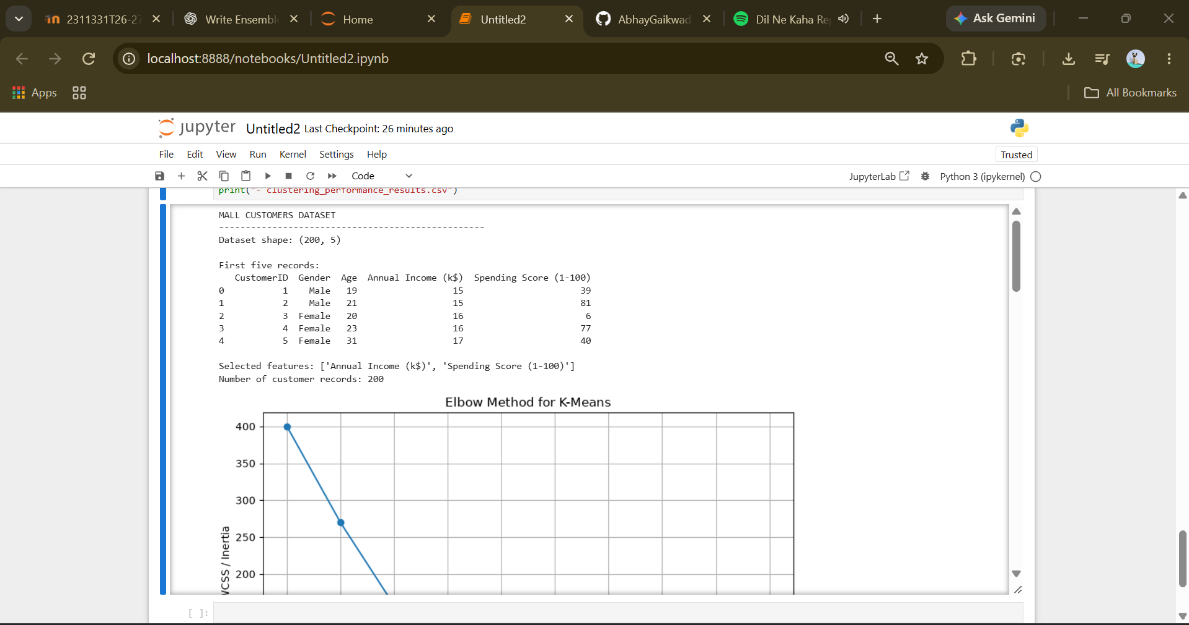
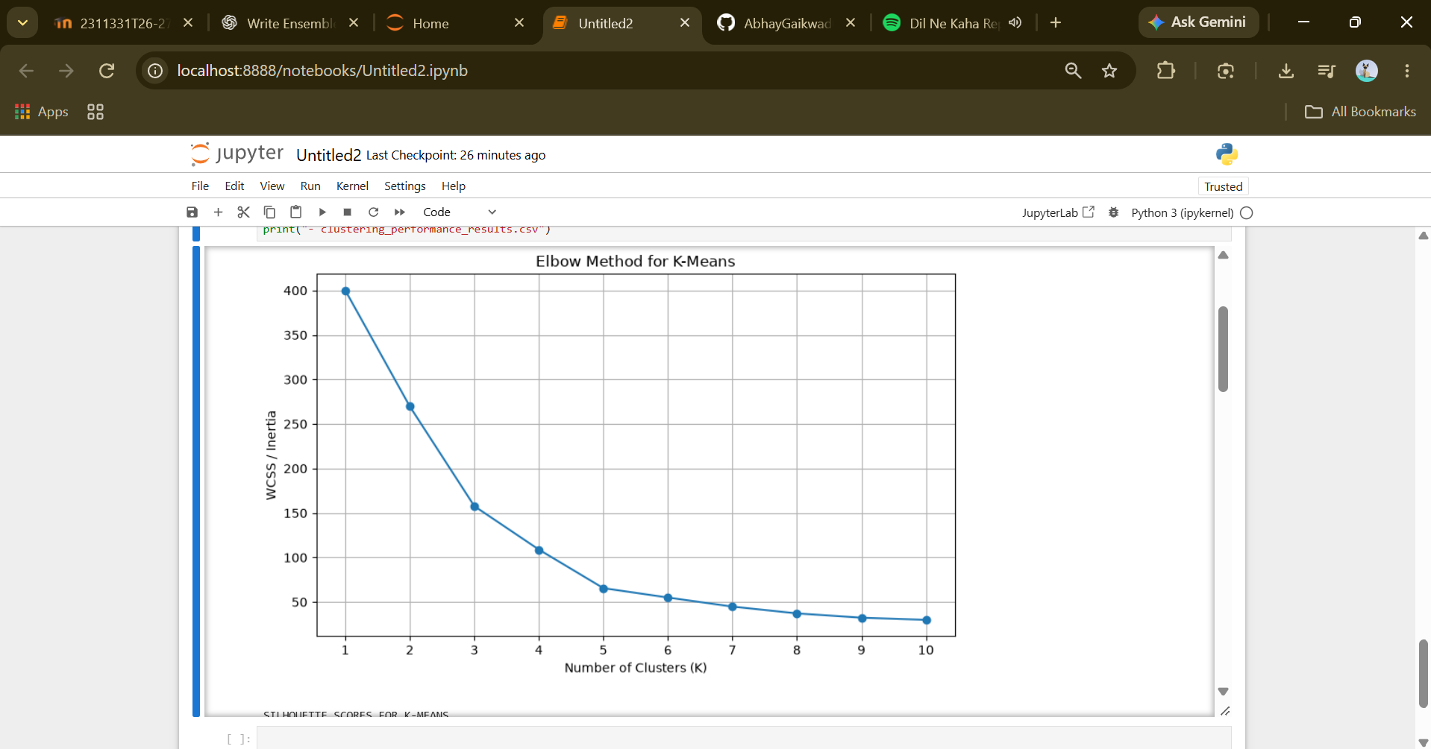

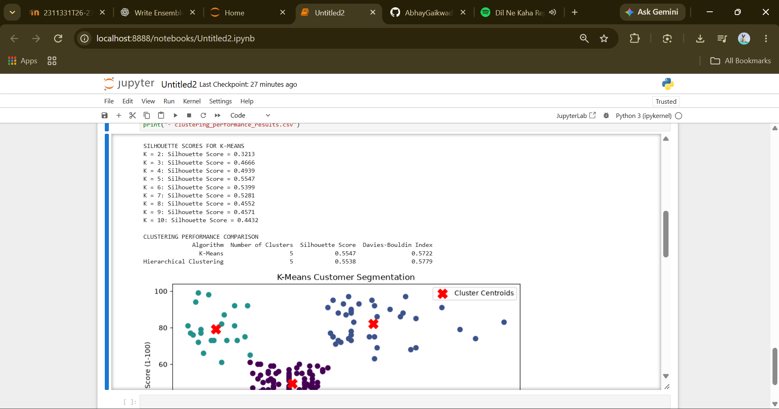

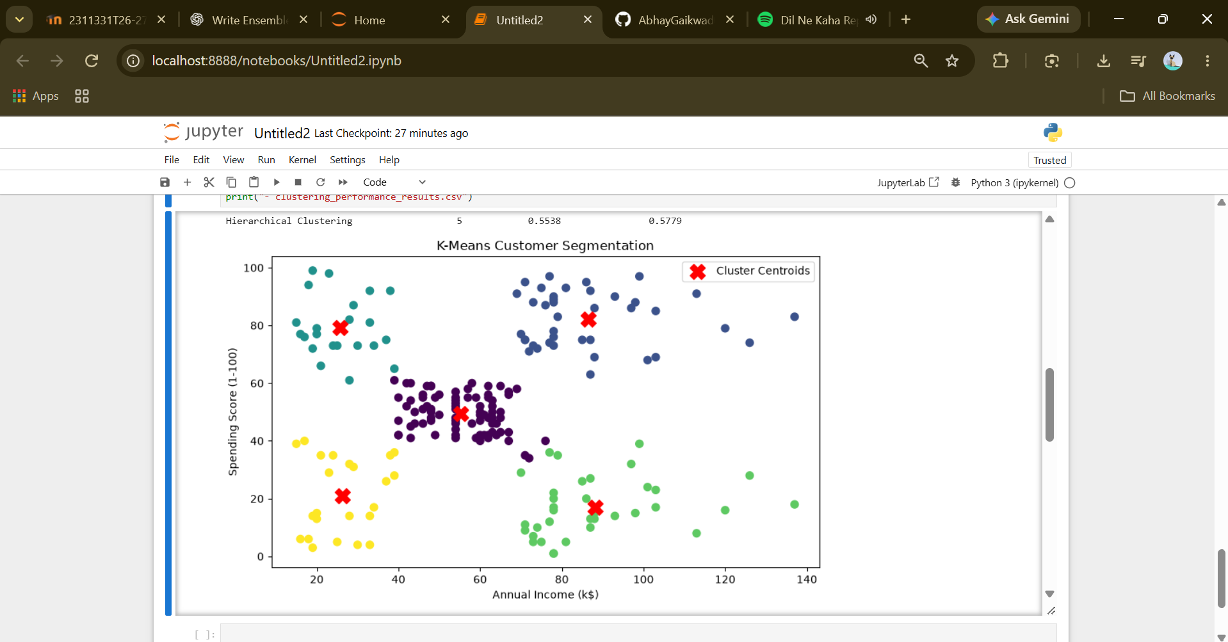

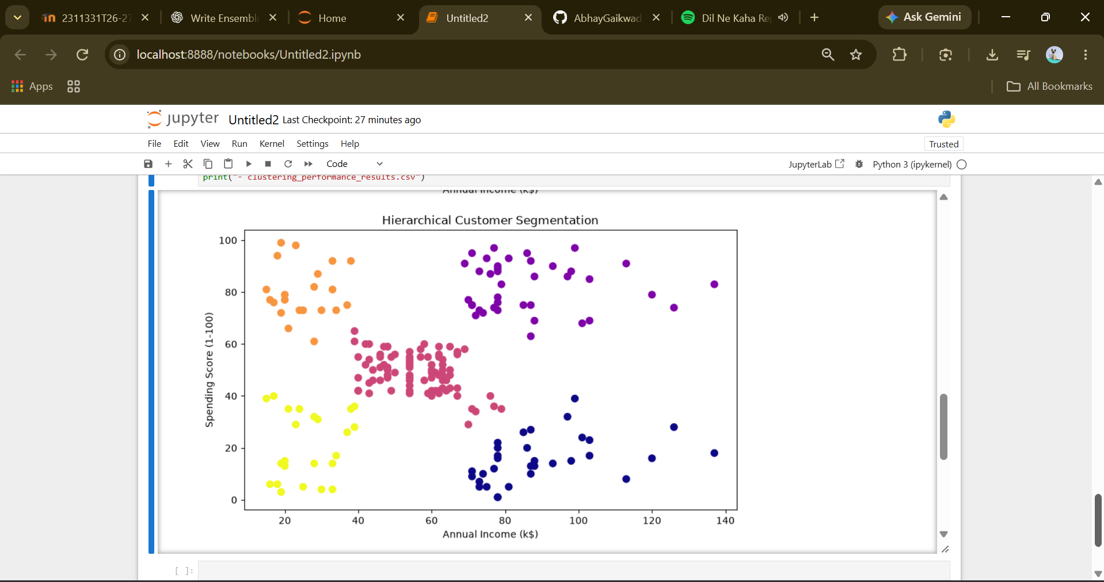
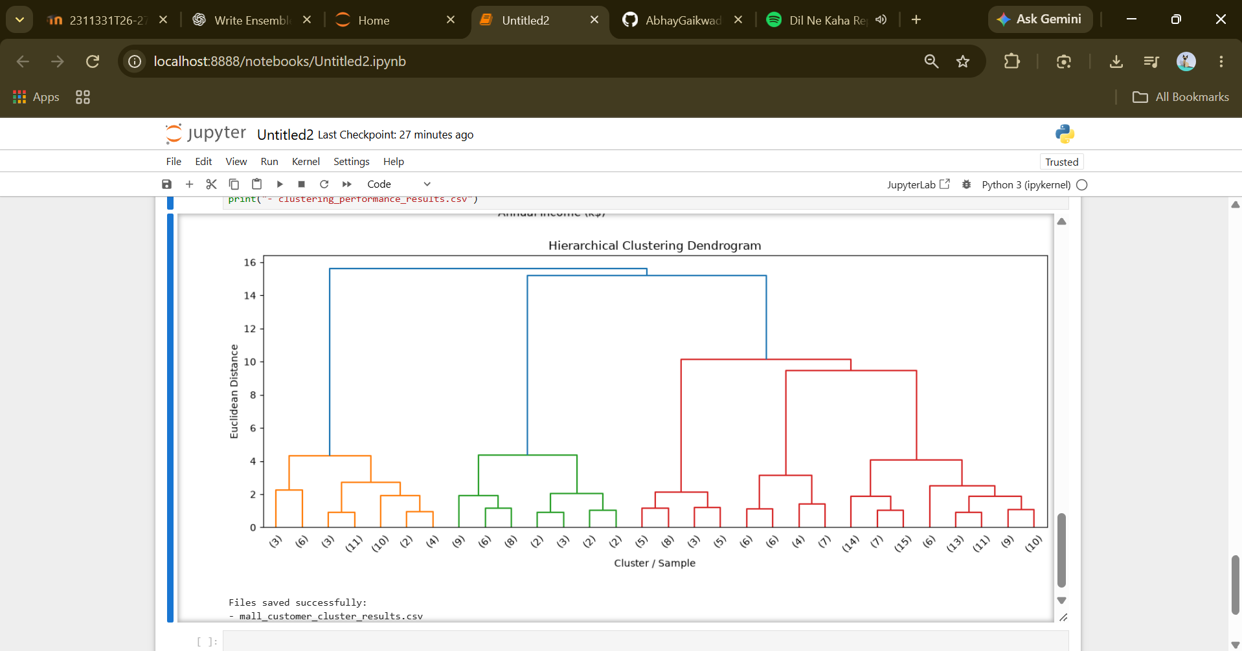
13. Performance Evaluation / Analysis:
- K-Means groups customers according to their distance from cluster centroids.
- Hierarchical Clustering groups customers based on similarity and represents cluster relationships through a dendrogram.
- The Elbow Method helps identify a suitable cluster count by examining the reduction in WCSS.
- A higher Silhouette Score generally indicates better-defined clusters.
- A lower Davies–Bouldin Index generally indicates more compact and well-separated clusters.
- Cluster visualizations help identify groups of customers with different income and spending characteristics.
- The two algorithms may generate different cluster assignments because their clustering mechanisms differ.

13.1 K-Means Clustering
K-Means is computationally efficient and suitable for customer segmentation when groups can be represented reasonably well by their centroids. It is easy to implement and interpret. However, its performance depends on the number of clusters, initialization, feature scaling, and the distribution of the data.

13.2 Hierarchical Clustering
Hierarchical Clustering provides a hierarchy of customer groups and uses a dendrogram to illustrate their relationships. It does not require random centroid initialization. However, it can be computationally expensive for larger datasets, and its results depend on the distance and linkage criteria.

13.3 Evaluation Metrics
The Silhouette Score measures how well-separated and cohesive the clusters are. The Davies–Bouldin Index evaluates cluster compactness relative to cluster separation. Both are internal evaluation metrics, meaning that they assess the clustering structure without requiring predefined class labels.
Neither metric should be used in isolation. Visual inspection, the business context, and the usefulness of the discovered customer groups should also influence the final selection.
14. Conclusion:
This practical implements K-Means and Hierarchical Clustering using the Mall Customers Dataset to identify meaningful customer groups based on annual income and spending score.
The Elbow Method and Silhouette Score are used to help select the number of clusters, while the Silhouette Score and Davies–Bouldin Index are used to evaluate clustering quality. Scatter plots and a dendrogram provide visual insight into the resulting groups.
K-Means offers an efficient centroid-based approach, whereas Hierarchical Clustering provides a hierarchical representation of customer similarities. The experiment demonstrates the importance of preprocessing, feature scaling, cluster selection, and appropriate evaluation metrics in unsupervised learning.
The final algorithm should be selected using the actual experimental results and the usefulness of the identified customer segments.
15. Implementation / Source Code:
import pandas as pd
import numpy as np
import matplotlib.pyplot as plt
from sklearn.preprocessing import StandardScaler
from sklearn.cluster import KMeans, AgglomerativeClustering
from sklearn.metrics import silhouette_score, davies_bouldin_score
from scipy.cluster.hierarchy import dendrogram, linkage

# 1. Load the dataset
df = pd.read_csv("Mall_Customers.csv")
print("MALL CUSTOMERS DATASET")
print("-" * 50)
print("Dataset shape:", df.shape)
print("\nFirst five records:")
print(df.head())

# 2. Select clustering features
features = [
"Annual Income (k$)",
"Spending Score (1-100)"
]
X = df[features].copy()
# 3. Handle missing values
X = X.fillna(X.median())
# 4. Standardize features

scaler = StandardScaler()
X_scaled = scaler.fit_transform(X)
print("\nSelected features:", features)
print("Number of customer records:", len(X))

# 5. Elbow Method
wcss = []
for k in range(1, 11):
model = KMeans(
n_clusters=k,
random_state=42,
n_init=10
)
model.fit(X_scaled)
wcss.append(model.inertia_)

plt.figure(figsize=(8, 5))
plt.plot(range(1, 11), wcss, marker="o")
plt.title("Elbow Method for K-Means")
plt.xlabel("Number of Clusters (K)")
plt.ylabel("WCSS / Inertia")
plt.xticks(range(1, 11))

plt.grid(True)
plt.tight_layout()
plt.show()
# 6. Compare silhouette scores for different K values
print("\nSILHOUETTE SCORES FOR K-MEANS")
for k in range(2, 11):
model = KMeans(
n_clusters=k,
random_state=42,
n_init=10
)
labels = model.fit_predict(X_scaled)

score = silhouette_score(X_scaled, labels)
print(f"K = {k}: Silhouette Score = {score:.4f}")

# 7. Fit K-Means with five clusters
# Five clusters are a common starting point for this dataset.
kmeans = KMeans(
n_clusters=5,
random_state=42,
n_init=10

)
kmeans_labels = kmeans.fit_predict(X_scaled)
# 8. Fit Hierarchical Clustering
hierarchical = AgglomerativeClustering(
n_clusters=5,
linkage="ward"
)

hierarchical_labels = hierarchical.fit_predict(X_scaled)
# 9. Evaluate both algorithms
results = []
for name, labels in [
("K-Means", kmeans_labels),
("Hierarchical Clustering", hierarchical_labels)
]:
silhouette = silhouette_score(X_scaled, labels)
db_index = davies_bouldin_score(X_scaled, labels)
results.append({
"Algorithm": name,
"Number of Clusters": len(np.unique(labels)),
"Silhouette Score": silhouette,
"Davies-Bouldin Index": db_index
})

results_df = pd.DataFrame(results)
print("\nCLUSTERING PERFORMANCE COMPARISON")
print(results_df.round(4).to_string(index=False))
# 10. Visualize K-Means clusters
plt.figure(figsize=(8, 5))

plt.scatter(
X.iloc[:, 0],
X.iloc[:, 1],
c=kmeans_labels,
cmap="viridis",
s=50
)
centers = scaler.inverse_transform(kmeans.cluster_centers_)

plt.scatter(
centers[:, 0],
centers[:, 1],
marker="X",
s=200,
color="red",
label="Cluster Centroids"
)

plt.title("K-Means Customer Segmentation")
plt.xlabel("Annual Income (k$)")
plt.ylabel("Spending Score (1-100)")
plt.legend()
plt.tight_layout()
plt.show()

# 11. Visualize Hierarchical Clustering
plt.figure(figsize=(8, 5))

plt.scatter(
X.iloc[:, 0],
X.iloc[:, 1],
c=hierarchical_labels,
cmap="plasma",
s=50
)
plt.title("Hierarchical Customer Segmentation")
plt.xlabel("Annual Income (k$)")
plt.ylabel("Spending Score (1-100)")

plt.tight_layout()
plt.show()
# 12. Generate a dendrogram
linked = linkage(X_scaled, method="ward")

plt.figure(figsize=(12, 5))
dendrogram(linked, truncate_mode="lastp", p=30)
plt.title("Hierarchical Clustering Dendrogram")
plt.xlabel("Cluster / Sample")
plt.ylabel("Euclidean Distance")
plt.tight_layout()
plt.show()

# 13. Save cluster assignments
output_df = df.copy()
output_df["KMeans_Cluster"] = kmeans_labels
output_df["Hierarchical_Cluster"] = hierarchical_labels
output_df.to_csv("mall_customer_cluster_results.csv", index=False)
results_df.to_csv("clustering_performance_results.csv", index=False)
print("\nFiles saved successfully:")
print("- mall_customer_cluster_results.csv")
print("- clustering_performance_results.csv")

16. Student Declaration
I hereby declare that the above practical work has been completed by me and that the implementation, analysis, and answers are my own work.

Student Name | PRN | Signature
Abhay R. Gaikwad | 202401100146 | 

